**Department of Applied Physics, Delhi Technological University**

**Email: Depth.dtu@ac.in**

**DelTech Physics and Tech Hub ( DEPTH ) | Research Hackathon | INVICTUS’23**

|  |
| --- |
|  |

## Repeating FRBs Observation Simulations

* **Introduction**:

FRBs are brief, intense radio emissions that last a few milliseconds and originate from an unknown source. The first FRB was discovered in 2007, and since then, several dozen have been discovered, resulting in extensive research on the subject. Despite extensive research, the origin of FRBs is still unknown, making it one of the most fascinating astronomical phenomena in recent years.

* **Candidates for the Fast Radio Burst:**

Several theories have been put forward to explain the origin of FRBs, including collapsed stars, extragalactic objects, and even extraterrestrial signals. However, the most prominent candidates are:

* Neutron Star Mergers: According to this theory, FRBs are the result of two neutron stars merging, releasing a massive amount of energy in the process. The discovery of a repeating FRB near a massive galaxy supports this theory, implying that the source is a neutron star merger. For example, it could have frequencies as high as 8 GHz.
* Flaring Magnets: This theory suggests that FRBs are a result of the release of energy from a magnetic star, such as a pulsar or a magnetar. The sudden release of energy creates a short burst of radio waves, which are then detected as an FRB. For example, it could have frequencies as high as 1 GHz.
* Extragalactic Objects: This theory suggests that FRBs are a result of an astronomical event occurring in another galaxy, such as a supernova or a black hole. For example, it could have frequencies in range of KHz.
* **Ways to Discover/Detect Fast Radio Bursts:**
* RadioTelescopes: The primary tool for detecting FRBs is radio telescopes. The size and sensitivity of the telescopes are important factors in detecting these bursts. Larger, more sensitive telescopes, such as the Canadian Hydrogen Intensity Mapping Experiment (CHIME) and the Australian Square Kilometer Array Pathfinder (ASKAP), have detected a significant number of FRBs.
* Machine Learning Algorithms: To classify radio signals and determine whether they are FRBs, machine learning algorithms can be used. This allows astronomers to identify FRBs more quickly and efficiently, saving time and resources that would otherwise be spent manually analyzing the signals. CNN, SVM, RF Classifier, etc.
* **Repeating FRBs**: Repeating FRBs are crucial in understanding the origin of FRBs, as they provide an opportunity to observe the same burst multiple times. Detecting repeating FRBs is crucial in determining the location of the source and unlocking the secrets of the phenomenon.
* **Our Goal:**

To identify if there is any selection effect a telescope would show in discovering/detecting periodically repeating FRBs

* **Simulating Repeating FRB data :**

To simulate an FRB, we need to generate its observational parameters. These are as follows:

1. Right ascension (RA)
2. Declination (Dec)

FRBs are seen to be uniformly distributed over the entire sky ⇒ RA = [0, 360) deg, DEC= [-90, 90) deg

1. Period (P) Assume periods are uniformly distributed [1, 200] days
2. Duty cycle (D) Assume the duty cycle coming uniformly from [0.1, 0.5)
3. Start Phase (phs) Assume the start phase from [0, 1)
4. A reference epoch (that is “”).

All these parameters will be randomly generated (a uniform distribution because we really do not know what distribution these parameters would take) between the given range, and to reproduce the same set of randomly generated numbers, we need to keep track of the seed number. After all these parameters are generated, we need to repeat this for multiple FRBs. A set of FRBs with an associated seed number is created and saved.

* **Simulating The Telescope:**

Simulating a telescope basically means predicting what part of the sky it will see and how it will change during the course of time. For this, the location and altitude of the telescope are required.

**Our Telescope:**

**Image:**

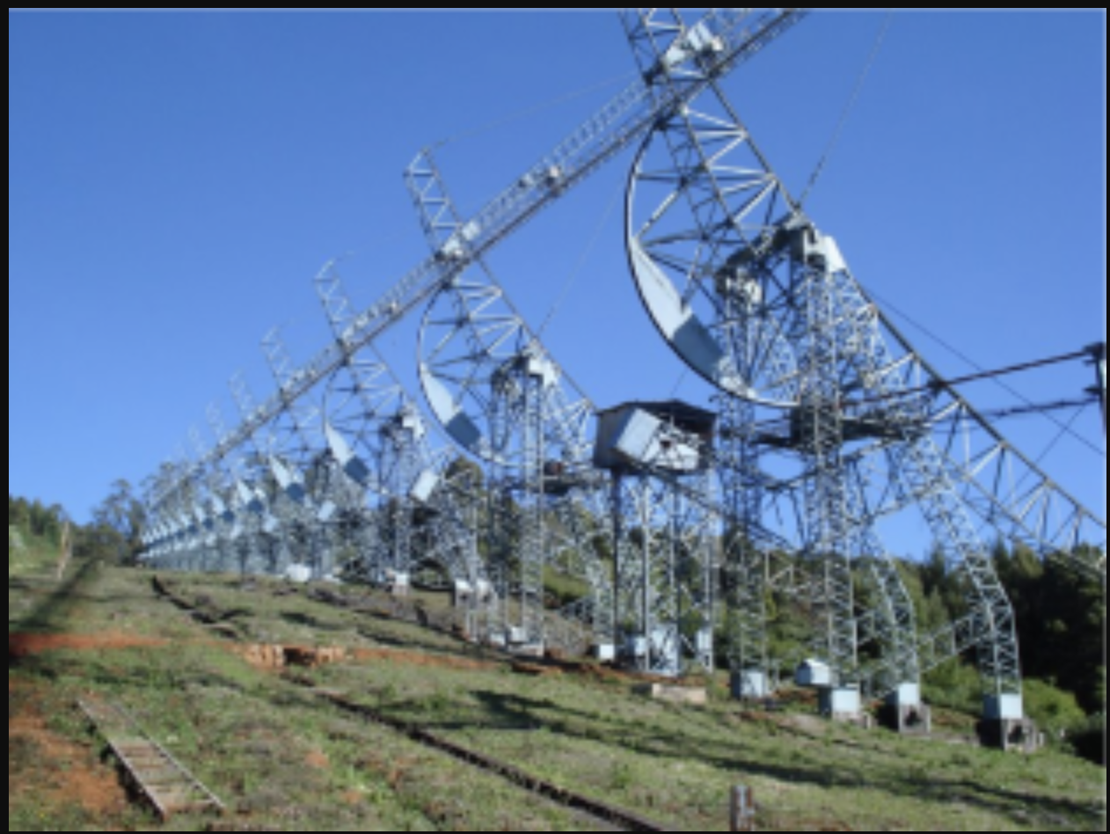

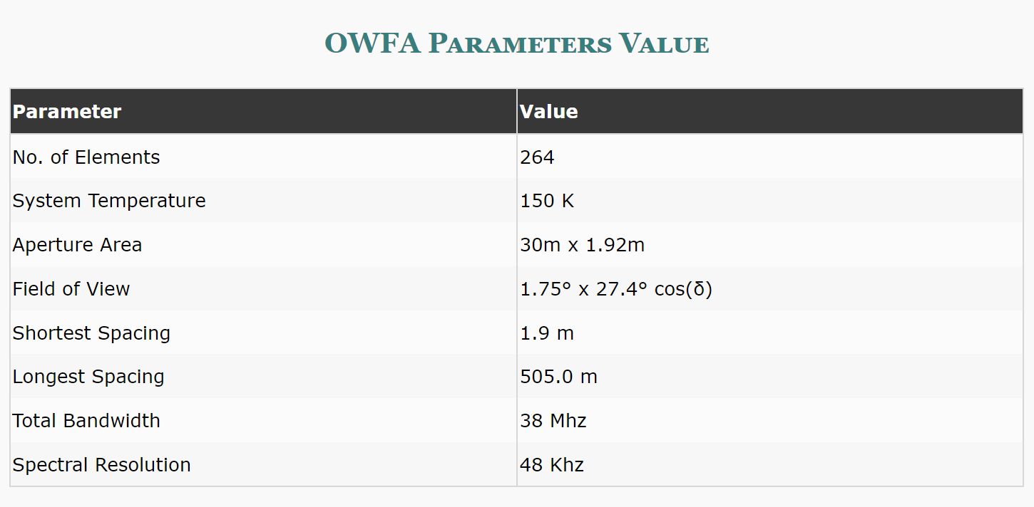

Source of image: <http://rac.ncra.tifr.res.in/ort/owfa.html>

For this project we will simulate Ooty Radio Telescope, it is located in the southern state of Tamil Nadu, India. The coordinates of the Ooty Radio Telescope are approximately 11.4047° N, 76.7254° E. The altitude of the observatory is approximately 2,200 meters (7,218 feet) above sea level.

Here we assume our telescope as transit-type (immovable) radio telescopes, we had to simulate its field of view/ beam as well. For ORT, it happens to be roughly in the shape of an ellipse, and its center is positioned at the zenith. Precisely, N-S = 27.4 deg and E-W = 2-3 deg.

* **What do we mean by observed ? :**

Consider a repeating FRB source we simulate. Its position in the sky has to be calculated for every minute of each day for two years continuously. Then check whether at any point this source passes through the field of view/beam of the telescope. The entry and exit time of the source crossing the beam has to be noted, including all of its other simulated parameters like RA ,Dec, Period, Duty Cycle, Phase and then this source will be considered as observed.

* **Detecting the Active and Repeating FRB from our Ooty Radio Telescope:**

**Code:-**

Installing/Updating required Libraries:

# installing required libraries

!pip install astroplan

!pip3 install --upgrade pandas

Code for simulating and plotting FRB data:

# FRB data simulation and plotting code

import numpy as np

import random

import matplotlib.pyplot as plt

import pandas as pd

import os

from astroplan import Observer

##########################

def getdata(num, seed):

    n=num #Number of sources/data points to be generated

    s=seed  #seed value for random

    ##################################

    #Generating various parameters

    #print("Simulaiting data...")

    np.random.seed(s)

    RA=np.random.uniform(0, 359.999, n)

    Dec=np.random.uniform(-90, 89.999, n)

    period=np.random.uniform(1, 200, n) #period in days

    d_cycle=np.random.uniform(0.01,0.499, n) #duty cycle

    s_phase=np.random.uniform(0, 0.999, n) #start phase

    name=[("sample_%d_%d"%(s,i)) for i in range(n)]

    ##############################

    #Coverting into DataFrame and saving as CSV file

    #print("Saving data...")

    val = list(zip(name,RA, Dec,period,d_cycle,s_phase))

    df = pd.DataFrame(val, columns=['Name','RA', 'Dec','Period','Duty_cycle','phase'])

    outdir = 'simulated_data_ORT'

    if not os.path.exists(outdir):

        os.mkdir(outdir)

    #df.to_csv("simulated_frb(%d,%d).csv"%(n,s))

    df.to_csv(f"{outdir}/simulated_frbs(%d,%d).csv"%(n,s))

    print("Data file saved successfully")

    return(df)

###############################

def plot(data):

    #plotting frbs ins sky

    resp= input("Do you want to visualize distribution of simulated FRB sources in sky? [Y/N]: ")

    resp=resp.upper()

    if resp=='Y':

        RA=data.RA

        Dec=data.Dec

        plt.scatter(RA,Dec,s=0.5)

        plt.title("FRBs in sky")

        plt.xlabel('RA')

        plt.xticks(range(0, 360,60))

        plt.ylabel('Dec')

        plt.yticks(range(-90, 90,20))

        plt.grid()

        plt.show()

        # change for optimization (remove append using for with direct numpy operation)

        RA[RA > 180] = RA[RA > 180] - 360

        RA_rad=np.deg2rad(RA)

        Dec_rad=np.deg2rad(Dec)

        #degress into radians, required for projection

        # for i in range(len(RA)):

        #     RA_rad.append(np.deg2rad(RA[i]))

        #     Dec_rad.append(np.deg2rad(Dec[i]))

        fig = plt.figure(figsize = (6,6))

        #changed subplot 111 to 221

        ax = fig.add_subplot(221, projection='mollweide')

        ax.scatter(RA_rad, Dec_rad, s=1, marker='o', color='b')

        ax.grid(True)

        plt.title('FRBs in sky')

        plt.xlabel('RA')

        plt.ylabel('Dec')

        plt.show()

    else:

        print("Invalid input")

Code to Generate FRB Data and Observe it Using the Observer Object of a Telescope:

# Code to Generate FRB Data and Observe it Using the Observer Object of a Telescope

import os

import numpy as np

import pandas as pd

import matplotlib.pyplot as plt

import matplotlib

import astropy.units as u

from astropy.time import Time

from astroplan import Observer

import warnings

import time

import gc

#new imports

# #user defined file

# import simulate

n= 4100 #number of repeating FRBs

ndatasets= 5 #Number of Datasets to be generated, saved, and analysed

ndays= 2*365 #Number of observation days for a given dataset

R= Time('2000-01-01T12:00:00') #reference epoch

ort= Observer(longitude=76.666*u.deg, latitude=11.384*u.deg,elevation=0*u.m, name="ORT")

lat= ort.location.lat.rad #ORT Latitude in radian

#Beam ellipse, x and y are points to check

a= 1.75/2 #semi-minor axis

b= 27.4/2 #Semi-major axis

h= 180 #center point az

k= 90 #center point alt

h2= 0

k2= 90

h3= 360

k3= 90

for nd in range(ndatasets): #range of seed values, one can put a perticular range as well eg. range(5,10)

    st = time.time()

    print("Dataset: %d"%(nd+1))

    #make sure that getdata method definition is executed in above cell before running this code

    data=getdata(n, nd+1) #n= number of FRBs, i+1 = Seed for random numbers

    data.drop(data[data['Dec'] <= -20].index, inplace=True) #below declination -20 is outside the CHIME/FRB field of view

    data= data.reset_index(drop=True) #reindexing

    RA=data.RA

    Dec=data.Dec

    phs=data.phase #start phase

    P=data.Period

    D= data.Duty_cycle

    obs_frbs=[] #Observed FRBs

    ent= []

    ext= []

    new_phs=[]

    # added for plotting Alt-Az for FRB (for running this first comment the plot(obs_frbs) then run it)

    # plt.title("Alt-Az plot for FRBs 2 days and for 20 FRB perdataset") # this is done for clarity of plot

    # plt.ylabel('Azimuth [deg]')

    # plt.xlabel('Altitude [deg]')

    for i in range(ndays):

        #print("Day:",i)

        T= Time('2018-01-01T12:00:00') #time T

        T= T+i*u.day

        P=data.Period #start phase

        new_phs= ((T.mjd-R.mjd)%P)/P

        x1= new_phs<=0.5+0.5*D

        x2= new_phs>=0.5-0.5*D

        x= x1 & x2

        Act_frbs= data[x] #Active FRBs

        Act_frbs= Act_frbs.reset_index(drop=True)

        start= T

        end= T+1*u.day

        twin= start + (end - start) * np.linspace (0, 1, 1440) # Observing every minute

        ra= Act_frbs.RA

        dec= np.deg2rad(Act_frbs.Dec) #in radians

        lst= ort.local_sidereal_time(twin.value).deg

        my_saa= []

        #Converting Equatorial (RA-Dec) into horizontal (Alt-Az) coordinates for ORT

        for j in range(len(ra)): #loop to calculate for each source

            ha= np.deg2rad(lst-ra[j])

            #if HA value is in negative, add 360 to it

            ha[np.where(ha<=0)]+= 2*np.pi

            alt= np.arcsin(np.sin(dec[j])*np.sin(lat) + np.cos(dec[j])*np.cos(lat)*np.cos(ha))

            az= np.arccos((np.sin(dec[j]) - np.sin(alt)*np.sin(lat))/(np.cos(alt)*np.cos(lat)))

            alt= np.rad2deg(alt)

            az= np.rad2deg(az)

            #if sin(HA) is positve, subtract az from 360

            m= np.sin(ha)>0

            az[m]= 360-az[m]

            my_saa.append([alt, az])

            # if (i<2 and j<20):

            #     plt.plot(alt,az)

        #Determining active FRBs passing through beam region, and when (entry and exit time)

        for m in range(len(my_saa)):

            x= my_saa[m][1]

            y= my_saa[m][0]

            r= (pow((x - h), 2) / pow(a, 2)) + (pow((y - k), 2) / pow(b, 2));

            #r<1 inside, r=1 on the ellipse, r>1 outside

            r= r<=1

            r2 = (pow((x - h2), 2) / pow(a, 2)) + (pow((y - k2), 2) / pow(b, 2));

            r2= r2<=1

            r3 = (pow((x - h3), 2) / pow(a, 2)) + (pow((y - k3), 2) / pow(b, 2));

            r3= r3<=1

            r2+= r3

            r+= r2

            if r.sum()>=1: #checking if at any point passes through beam region

                dr= np.diff(r, prepend=0) #differentiating and adding 0 in front.

                sp= np.where(dr!=0)[0] #checking change in values, from true to false or vice versa.

                if len(sp)%2!=0:

                    sp= np.append(sp, sp[-1]+1) #adding value to make it even

                    sp= sp.reshape((-1, 2))

                    [ent.append( start+ ((end - start) * (l/len(twin))) ) for l in sp[:,0]]

                    [ext.append( start+ ((end - start) * (l/len(twin))) ) for l in sp[:,1]]

                    for l in range(len(sp)): obs_frbs.append(Act_frbs.iloc[m])

                else:

                    sp= sp.reshape((-1, 2)) #dividing in entry and exit

                    [ent.append( start+ ((end - start) * (l/len(twin))) ) for l in sp[:,0]]

                    [ext.append( start+ ((end - start) * (l/len(twin))) ) for l in sp[:,1]]

                    for l in range(len(sp)): obs_frbs.append(Act_frbs.iloc[m])#indexing is same for Act_frbs

    obs_frbs= pd.DataFrame(obs_frbs)

    obs_frbs= obs_frbs.reset_index(drop=True)

    #plotting the observed frbs in sky (run this by commenting Alt-Az plot)

    plot(obs_frbs)

    #Saving all observed frbs in file

    outdir = '/Observed_FRBs_Vanilla_ORT'

    if not os.path.exists(outdir):

        os.mkdir(outdir)

    st2 = time.time()

    #Adding entry and exit times into dataframe obs_frbs

    obs_frbs= pd.concat([obs_frbs, pd.DataFrame(ent, columns=["Entry_time"]), pd.DataFrame(ext, columns=["Exit_time"])], axis = 1)

    #df.to_csv(f"{outdir}/observed_frbs(%s).csv"%(nd+1)) #saving as csv file

    np.savetxt(f"{outdir}/observed_frbs(%s).csv"%(nd+1), obs_frbs.values, fmt='%s,%.6f,%.6f,%.6f,%.6f,%.6f,%s,%s', header=','.join(obs_frbs.columns), comments='')

    print("Observed data file saved successfully")

    print(f'For saving data: {time.time() - st2} seconds')

    print(f'For One 2 years run: {time.time() - st} seconds')

    del obs_frbs

    del my_saa

    gc.collect()

    plt.show()

Code Reference and credit: theanish37 **(**[GitHub - theanish37/RFRB_simulator](https://github.com/theanish37/RFRB_simulator)**)**

(Run the code cells in given order)

**Code Explanation: -**

This code simulates the observation of Fast Radio Bursts (FRBs) from the ORT (Ooty Radio Telescope). It generates n datasets of n FRBs each, for n days of observation. It then determines when each FRB is visible to ORT based on their RA/Dec positions and the ORT's latitude/longitude/elevation. It checks if any of the FRBs passes through the beam region of ORT, and if so, determines the entry and exit times for the FRB. The code outputs observed FRBs and the entry and exit times for the beam region.

**Output:**

Dataset: 1

Data file saved successfully

Do you want to visualize distribution of simulated FRB sources in sky? [Y/N]: Y

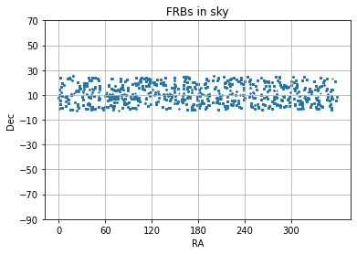

RA[RA > 180] = RA[RA > 180] - 360

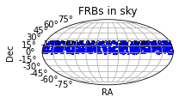

Observed data file saved successfully

For saving data: 13.26909327507019 seconds

For One 2 years run: 394.71124291419983 seconds

Dataset: 2

Data file saved successfully

Do you want to visualize distribution of simulated FRB sources in sky? [Y/N]: Y

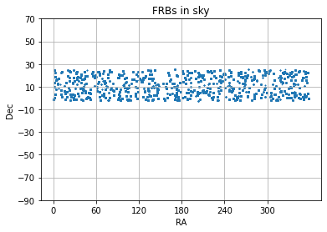

RA[RA > 180] = RA[RA > 180] - 360

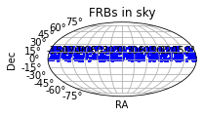

Observed data file saved successfully

For saving data: 13.532166004180908 seconds

For One 2 years run: 397.054719209671 seconds

Dataset: 3

Data file saved successfully

Do you want to visualize distribution of simulated FRB sources in sky? [Y/N]: Y

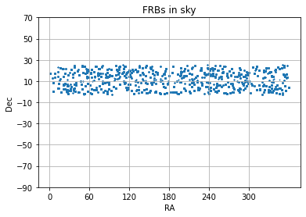

RA[RA > 180] = RA[RA > 180] - 360

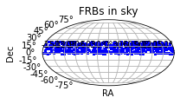

Observed data file saved successfully

For saving data: 12.251473426818848 seconds

For One 2 years run: 379.32392144203186 seconds

Dataset: 4

Data file saved successfully

Do you want to visualize distribution of simulated FRB sources in sky? [Y/N]: Y

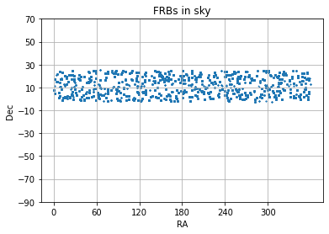

RA[RA > 180] = RA[RA > 180] - 360

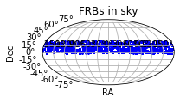

Observed data file saved successfully

For saving data: 13.257020711898804 seconds

For One 2 years run: 398.14992451667786 seconds

Dataset: 5

Data file saved successfully

Do you want to visualize distribution of simulated FRB sources in sky? [Y/N]: Y

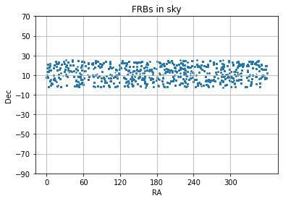

RA[RA > 180] = RA[RA > 180] - 360

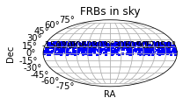

Observed data file saved successfully

For saving data: 12.326771974563599 seconds

For One 2 years run: 397.77538323402405 seconds

* **Some other Plots and Inferences from the Result and Observation of data:-**

**Files created:-**

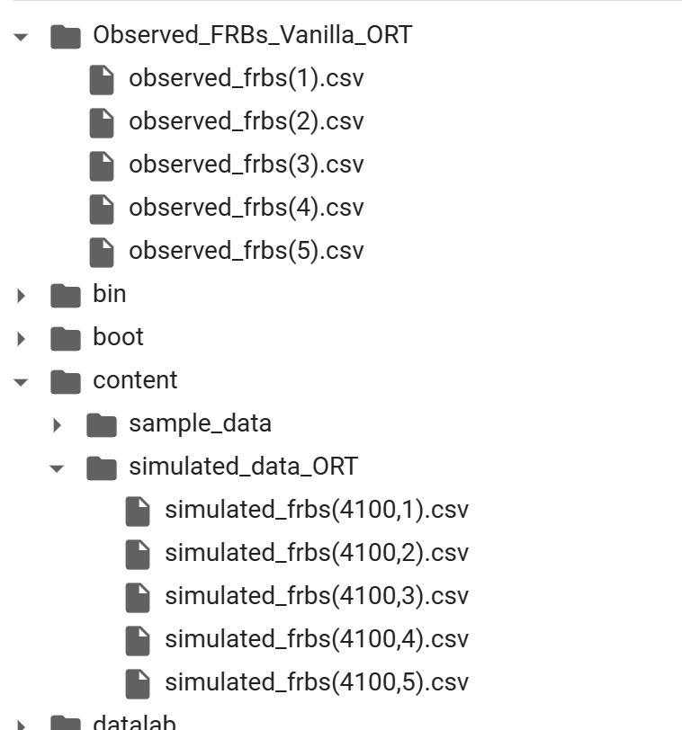

**Link of output csv Files:-**

<https://drive.google.com/drive/folders/1OuDltliZNH2WHGnEflrOuvk7BrnoLSsx?usp=sharing>

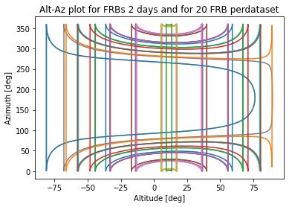

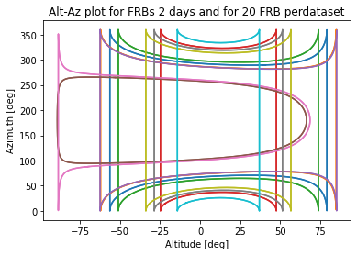

**Beam size difference of Ooty Radio telescope and CHIME telescope:**

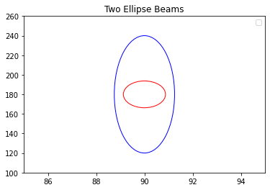

* **Inference from the data and observation and Effect of Structural and parameters on the properties of telescope:**

1. **Difference of dish structure and its effect:**

The Ooty Radio Telescope (ORT) and the Canadian Hydrogen Intensity Mapping Experiment (CHIME) telescope differ in their dish and structure designs. The ORT has a parabolic dish, while the CHIME telescope consists of cylindrical reflectors. The parabolic dish shape of ORT enables the collection of a broad range of frequencies, high directivity and sharp radiation angle which makes it an ideal instrument for low-frequency observations. On the other hand, the CHIME telescope's cylindrical reflectors are specifically designed to collect radio waves from specific regions of the sky. The structure of the CHIME telescope also allows it to capture radio signals from a much larger area of the sky compared to other radio telescopes. Overall, the difference in dish design affects the performance and effectiveness of each telescope in terms of its ability to capture and analyze specific frequencies, observe a wider or narrower field of view, and contribute to different areas of astronomical research.

1. **Effect of Difference in field of view:**

The field of view of the Ooty Radio Telescope (ORT) is smaller than that of the CHIME telescope. However, it is important to note that the CHIME telescope is fixed in place, while the ORT is movable. For simplicity, we have considered the ORT to be immovable in this analysis. As a result, the ORT has a smaller beam and a lower number of repeated Fast Radio Bursts (FRBs) observed for the same input data compared to the CHIME telescope.

In our observation, we found that the number of observed FRBs by the ORT was 66,897, while the CHIME telescope detected 489,688 FRBs. This significant difference is due to the difference in the field of view of the two telescopes. The smaller field of view of the ORT resulted in a smaller beam and a lower number of observed FRBs. However, it is important to note that the ORT's movable nature allows for flexibility in observing different regions of the sky, which can be useful for specific research projects. Overall, the difference in field of view between the ORT and the CHIME telescope has a significant impact on the number of observed FRBs and their potential for contributing to astronomical research.

1. **Effect of altitude difference:**

The Ooty Radio Telescope (ORT) has the advantage of being located at a high altitude of 2240m while the altitude of CHIME telescope is 545 m. This altitude provides a clear view of the sky and reduces the amount of atmospheric interference, resulting in high-quality observations. The higher altitude also reduces the impact of radio frequency interference (RFI) from nearby human settlements and reduces the amount of signal loss due to atmospheric absorption. Therefore, the high altitude of the ORT enhances the telescope's sensitivity and accuracy, making it an important tool for astronomical research.

1. **Difference of frequency in ORT and chime telescope and its Effect:**

The Ooty Radio Telescope (ORT) and the CHIME telescope operate at different frequencies. The ORT operating frequency is 320MHz while the operating frequency of Chime telescope is 400 to 800MHz.

The frequency at which a telescope operates has a significant impact on the type of signals it can detect and the level of detail it can capture. Lower frequency radio waves, like those observed by the ORT, are better suited for studying the large-scale structure of the universe, while higher frequency radio waves, like those observed by the CHIME telescope, provide better resolution of smaller objects and details in the sky. The ability to detect specific frequencies also affects the type of astronomical research that can be conducted, such as studying pulsars, galaxies, and the interstellar medium. In conclusion, the difference in operating frequency between the ORT and the CHIME telescope affects the type of observations they can make, their ability to capture details, and the types of astronomical research they can contribute to.

1. **Effect of Geographical Location on the Radio telescope (difference in location coordinates):**

The location coordinates of Ooty radio telescope are 11.383404 degrees north latitude and 76.66616 degrees east longitude, while the coordinates of CHIME telescope are 49.3208 degrees north latitude and 119.6236 degrees west longitude. The geographical location coordinates play a crucial role in the operation and performance of a telescope. The location of a telescope determines the amount of atmospheric distortion and interference it experiences, affecting the quality of the observations. The Ooty radio telescope is situated in the low-latitude region, which is beneficial for studying low-frequency radio waves. On the other hand, the CHIME telescope is located in a mountainous region with a low level of radio frequency interference, enabling it to detect and study radio signals with higher precision. Additionally, the location of a telescope determines the accessibility to celestial objects, which can vary based on latitude, longitude, and time of year. Therefore, the location of a telescope is a crucial factor in its effectiveness for scientific research.

* **Conclusion:**

In conclusion, the Ooty Radio Telescope (ORT) and the Canadian Hydrogen Intensity Mapping Experiment (CHIME) telescope differ in their dish and structure designs, field of view, altitude, operating frequency, and geographical location coordinates. These differences affect the telescopes' performance, sensitivity, accuracy, and ability to contribute to different areas of astronomical research. The ORT's parabolic dish and lower frequency range make it ideal for studying large-scale structures of the universe, while the CHIME telescope's cylindrical reflectors and higher frequency range provide better resolution of smaller objects and details in the sky. The ORT's smaller field of view limits its ability to detect repeated Fast Radio Bursts, but its movable nature allows for flexibility in observing different regions of the sky. The high altitude of the ORT reduces atmospheric interference, resulting in high-quality observations. The location coordinates of both telescopes impact the quality of their observations and accessibility to celestial objects. Overall, the differences in design and location make each telescope uniquely suited for specific research projects and contribute to the advancement of astronomical research.

Astro Hackers

Abhijit Kumar

(7488042190)

Thank you.